Series: Mark: Jesus, God’s Servant King! First Baptist Church
Topic: Fruit, Evangelism, Kingdom of God Pastor Jim Barnes
Text: Mark 4:21-34 April 21, 2024

What Is My Part In Building God’s Kingdom?

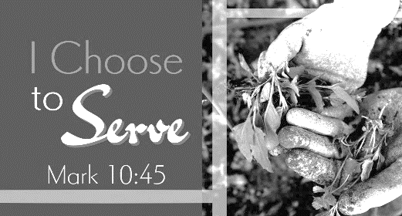
3 __________ God Wants Each _____________ To Faithfully _____________ To Do Our Part To See God’s Kingdom ______.

I. S_______ The __________ Of The Gospel __________ (Mark 4:21-25).

- You Are Not Supposed To __________________ It.

- You Are __________________ To ________________ It.

- You Will Be ____________________ Proportionately For It.

II. L_____ The _________ Of The Gospel Up To _______ (Mark 4:26-29).

- We Must Faithfully _______________________ The Seed.

- We Must _____________________ Wait.

- We Must _________________ The Lord To Give The _______________________.

III. B___________ God Is Doing A _____________ Work (Mark 4:30-34).

- God’s Kingdom Is Like A _________________ Seed – Starts ___________________.

- God’s Kingdom Will ________________ Surprisingly _________________.

Application:
We must share God’s Word with others!

If God were to measure the amount of God’s truth you share with others on a regular basis – how much would it be?

Circle One: (None) (Small Cup) (Large Cup) (Bucket)

What should you do this week to share God’s truth more with others?

WHAT IS A PARABLE?

Definition:
A parable is, literally, something “cast alongside” something else. Jesus’ parables were stories that were “cast alongside” a truth in order to illustrate that truth. His parables were teaching aids and can be thought of as extended analogies or inspired comparisons. A common description of a parable is that it is an earthly story with a heavenly meaning (Gotquestions.org).

* Sermon Graphics Courtesy of Noel Merritt

